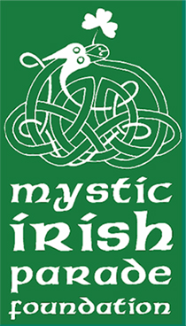
MYSTIC IRISH PARADE FOUNDATION
GRAND COLLEEN APPLICATION
ELIGIBILITY:
- FEMALE OR IDENTIFIES AS FEMALE
- HIGH SCHOOL JUNIORS AND SENIORS
- MUST CLAIM IRISH HERITAGE
- COMPLETION OF RESUME
Entries must be received by (March 1, 2024). The Grand Colleen will receive a $1000 scholarship and members of the court $500. The Colleen must attend the Grand Marshall Reception and The Mystic Irish Parade.
Applications can be mailed to the following address: PO Box 505 Mystic CT 06355 or emailed to echristi4@gmail.com. If you have any questions, feel free to contact Elizabeth Ryan (413) 262-4796 or email echristi4@gmail.com. Please include a resume.
Full Name________________________________
Address__________________________________
Home Phone______________________________
Email____________________________________
Parents Names __________________
High School and future education_________________________
Activities/ Awards_____________________
Community Involvement/Volunteerism_____________________
Hobbies/Interests_______________________
Colleen Questions
- How has your Irish heritage helped to shape the person you are today? Your answer should include what it’s like growing up in an Irish family and how the Irish culture has influenced you.
- What contributions have you made to your Irish and local community and your school activities?
We request essay answers to be limited to around 250 words.
Signature of applicant: __________________________________________
2024 permission to use photograph and biological information. I authorize the Mystic Irish Parade Foundation to use photographs of me and my biological information found on my application and a brief biography for educational and promotional purposes in any type of media, including our website. Initial __________

